Cord-Blood Research Sits Poised for Therapeutic Discovery
By Alan Trounson | March 27, 2015
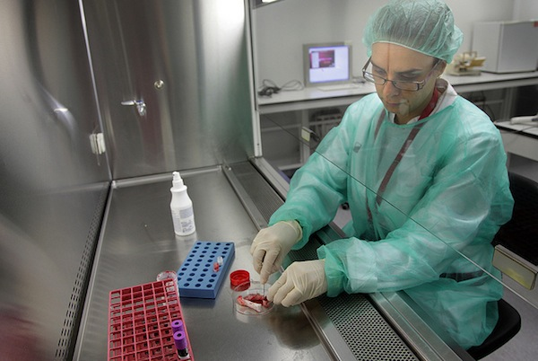
Whenever one examines any area of scientific inquiry, there are two important things to understand: where the science is today, and where it may lead us in the future. To examine only the former is to engage in half an inquiry and create the perception that things in this particular area have reached a dead end or are in some way, static.
That is the missing piece in a story published by Scientific American on December 5 entitled “Vast Majority of Life-Saving Cord Blood Sits Unused” because it focused on the present state of therapies alone. “Vast Majority of Life-Saving Cord Blood SitsPoised for Discovery” would be a far more apt headline for a proper examination of the opportunities being created by extensive research already ongoing in this promising area of medicine.
It is human nature to be disappointed when scientific progress appears slow, particularly when the goal is saving lives or dramatically improving the quality of life. As a society, we have grown accustomed to the incredible pace of advances in information technology, perhaps leading us to expect the same in areas like medicine when we learn that researchers have mapped the human genome. Sadly, new therapies simply don’t appear with the frequency of new mobile phones.
Indeed, the history of therapeutic research is full of instances where a promising technology is not fully realized until long after an initial discovery. Consider, for example, monoclonal antibodies: The initial discoveries, along with the seminal research by César Milstein and Georges Köhler, occurred in the 1970s—more than 20 years before there began to be a significant number of monoclonal antibody therapies approved for human use. Gene therapy had a similar timeline, with two decades elapsing between the initial concept, as proposed by Stanfield Rogers in 1970, and the first approved attempt to use gene therapy to treat a human patient for ADA-SCID in 1990.
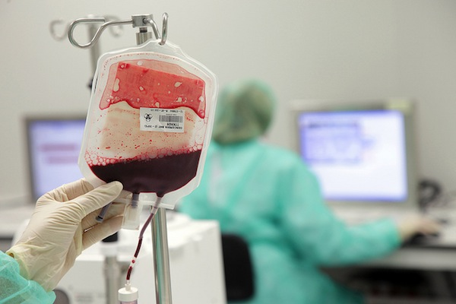
Blood from an umbilical cord. (Blood and Tissue Bank/Flickr)
There are now many clinical trials exploring strategies for therapies using genetically manipulated blood stem cell transplants for sickle cell disease, beta thalassemia and severe combined immunodeficiency (SCID)—see clinicaltrials.gov. Generally it takes 20 to 25 years to realize scientific discoveries. Another area that is presently receiving very significant development and investment is chimeric antigen receptor technology, which arms patients’ own killer T cells with tumor specific antibodies engineered to target transmembrane, signaling and enhancing molecules to rapidly and efficiently destroy lymphoblastic leukemias and other cancers. This work has been in development for more than 20 years.
The science of regenerative medicine is today in the midst of a similar incubation period. While there has been significant progress in research over the last decade, the potential for stem cell therapy based on newborn umbilical cord blood and cord tissue has only begun to emerge.
Research has demonstrated the safety of newborn cord blood stem cell therapies for recovery of hematopoietic function in pediatric disease with autologous and matched or a degree of mismatched transplants. Research is now underway on how newborn stem cells can support effective treatments for a much broader range of conditions—conditions for which there is a significant therapeutic need. Consider just three that have attracted preclinical and early clinical trials:
- Cerebral Palsy: The prevalence of cerebral palsy in births in the U.S. ranges from 3.1 to 3.6 per 1,000 annually, according to studies cited by the Centers for Disease Control and Prevention.
- Autism: Approximately one in 88 children in the U.S. suffers from autism, according to statistics from the National Institutes of Health.
- Type 1 diabetes: Approximately 1.25 million U.S. children and adults have type 1 diabetes according to statistics from the American Diabetes Association.
To identify and develop therapies for these and other serious human health conditions, there is a need to accelerate progress in this area of regenerative medicine by both replacing diseased or damaged cells, and using cell augmentation for intrinsic repair. Numerous academic institutions and some commercial cord blood organizations are now making significant investments toward these potential advancements. (I am connected with some of this work through my past and present affiliations with funding agencies, academia and private organizations like Cord Blood Registry, for which I am presently a scientific advisor.)
In fact, companies such as CBR have supported or directed additional trials that seek to establish regenerative therapies using autologous newborn stem cells that can be an effective approach to treating serious health problems in children and in adults. They include:
- A landmark FDA-regulated phase II clinical trial to assess the use of autologous stem cells derived from cord blood to improve language and behavior in certain children with autism. The trial, being conducted by Sutter Neuroscience Institute, involves 30 children, ranging in age from 2 to 7 years.
- An FDA-regulated phase I/II clinical trial conducted by Georgia Regents University to assess whether an infusion of autologous stem cells derived from their own cord blood can improve the quality of life for children with cerebral palsy. The target for the study is 40 children ranging in age from 1 to 12 years.
- An FDA-regulated phase I clinical trial at Florida Hospital for Children to investigate the use of a child’s stem cells derived from their own cord blood as atreatment for acquired sensorineural hearing loss.
- A pioneering FDA-regulated phase I/II clinical trial at the University of Texas Health Science Center to compare the safety and effectiveness of two forms of autologous stem cell therapy in children diagnosed with cerebral palsy. The randomized, double-blinded, placebo-controlled study aims to compare the safety and efficacy of an intravenous infusion of autologous cord blood stem cells to bone marrow stem cells. The study launched in November 2013 with a target of 30 children, ranging in age from 2 to 10 years.
With the recent demonstration of hematopoietic stem cell expansion, single cord blood units are being trialed to treat adult patients in life-saving therapies. This means that the stored cord blood samples can be used for family members as well as the child donor. Furthermore, data suggests that use of cord blood cells can be expanded 1,000-fold (or around 200-fold for the CD34+ stem cell population). Hence if these samples were tissue matched (HLA-typed) they could be used—with the donor or family consent—for others in need of blood stem cell transplants.
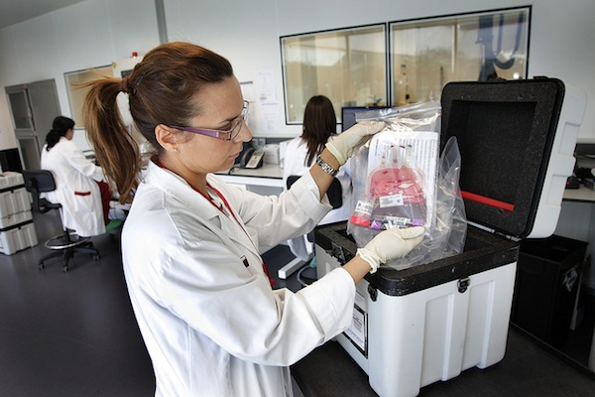
Cord blood being stored. (Blood and Tissue Bank/Flickr)
Imagine a radioactive spill disaster. These cord blood banks could save many lives. In addition, the discovery of induced pluripotent stem cells (iPSCs) could mean that these pristine umbilical cord blood and tissue cells could be reprogrammed and used for clinical applications throughout a family’s entire lifetime. Indeed, the enduring storage of cord blood units over 10-, 20- and soon 30-year timeframes will mean there is an incredible resource for the entire community.
Like the breakthroughs of past generations, realizing the potential of newborn stem cells in regenerative medicine will take both time and scientific rigor. Rather than dismiss them based on the state of the science today, we should all be asking how we all could contribute to the future potential of this emerging science.
As the evidence shows, progress in medicine takes time. So while these vital stem cells remain in storage today, the inevitable progress of ongoing research makes them an incredible resource for the near future.

